Overview of Application layer protocol

DNS(Domain Name System)
An application layer protocol defines how the application processes running on different systems, pass the messages to each other.
- DNS stands for Domain Name System.
- DNS is a directory service that provides a mapping between the name of a host on the network and its numerical address.
- DNS is required for the functioning of the internet.
- Each node in a tree has a domain name, and a full domain name is a sequence of symbols specified by dots.
- DNS is a service that translates the domain name into IP addresses. This allows the users of networks to utilize user-friendly names when looking for other hosts instead of remembering the IP addresses.
- For example, suppose the FTP site at EduSoft had an IP address of 132.147.165.50, most people would reach this site by specifying ftp.EduSoft.com. Therefore, the domain name is more reliable than IP address.
DNS is a TCP/IP protocol used on different platforms. The domain name space is divided into three different sections: generic domains, country domains, and inverse domain.
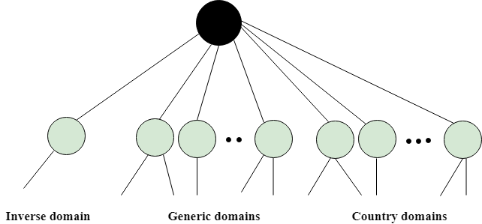

Generic Domains
- It defines the registered hosts according to their generic behavior.
- Each node in a tree defines the domain name, which is an index to the DNS database.
- It uses three-character labels, and these labels describe the organization type.
Label | Description
Aero | Airlines and aerospace companies
Biz | Businesses or firms
Com | Commercial Organizations
Coop | Cooperative business Organizations
Edu | Educational institutions
Gov | Government institutions
Info | Information service providers
Int | International Organizations
Mil | Military groups
Museum | Museum & other nonprofit organizations
Name | Personal names
Net | Network Support centers
Org | Nonprofit Organizations
Pro | Professional individual Organizations
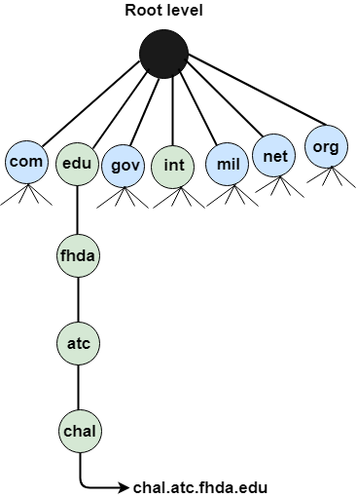

Country Domain
The format of country domain is same as a generic domain, but it uses two-character country abbreviations (e.g., us for the United States) in place of three character organizational abbreviations.

Inverse Domain
The inverse domain is used for mapping an address to a name. When the server has received a request from the client, and the server contains the files of only authorized clients. To determine whether the client is on the authorized list or not, it sends a query to the DNS server and ask for mapping an address to the name.

Working of DNS
- DNS is a client/server network communication protocol. DNS clients send requests to the. server while DNS servers send responses to the client.
- Client requests contain a name which is converted into an IP address known as a forward DNS lookups while requests containing an IP address which is converted into a name known as reverse DNS lookups.
- DNS implements a distributed database to store the name of all the hosts available on the internet.
- If a client like a web browser sends a request containing a hostname, then a piece of software such as DNS resolver sends a request to the DNS server to obtain the IP address of a hostname. If DNS server does not contain the IP address associated with a hostname, then it forwards the request to another DNS server. If IP address has arrived at the resolver, which in turn completes the request over the internet protocol.
DNS Protocol
The Domain Name System (DNS) protocol is a process that allows internet users to navigate the internet using hostnames instead of numeric IP addresses. DNS is like the phonebook of the internet; it simplifies the process of searching for specific websites through web browsers.
When a DNS client makes a DNS request using a hostname, such as www.example.com, a series of functions connect that request with the corresponding IP address. These functions provide the authentication of IP addresses (both IPv4 and IPv6) and make internet usage more accessible by translating customizable domain names into complex numerical addresses.
To complete these functions, DNS protocol relies on four types of DNS servers that, when functioning properly, make the process fast and secure. DNS servers use DNS records—records such as A records and CNAME records that contain information that guides the resolution process—to properly route DNS requests. These records are text-based files known as “zone files,” written in DNS syntax.
DNS resource records are stored on authoritative DNS servers also known as authoritative name servers. They contain information related to the domain, including how long a server will keep DNS records cached, a period known as time-to-live (TTL). These records enable the linking of domain and subdomains and the proper routing of emails, assist with DNS security and more.

Overview of WWW and HTTP

WWW(World Wide Web)

All public websites or web pages that people may access on their local computers and other devices through the internet are collectively known as the World Wide Web or W3. Users can get further information by navigating to links interconnecting these pages and documents. This data may be presented in text, picture, audio, or video formats on the internet.

What is WWW?
WWW stands for World Wide Web and is commonly known as the Web. The WWW was started by CERN in 1989. WWW is defined as the collection of different websites around the world, containing different information shared via local servers(or computers).
Web pages are linked together using hyperlinks which are HTML-formatted and, also referred to as hypertext, these are the fundamental units of the Internet and are accessed through Hyper Text Transfer Protocol(HTTP). Such digital connections, or links, allow users to easily access desired information by connecting relevant pieces of information. The benefit of hypertext is it allows you to pick a word or phrase from the text and click on other sites that have more information about it.

History of the WWW
It is a project created, by Tim Berner Lee in 1989, for researchers to work together effectively at CERN. It is an organization, named the World Wide Web Consortium (W3C), which was developed for further development of the web. This organization is directed by Tim Berner’s Lee, aka the father of the web. CERN, where Tim Berners worked, is a community of more than 1700 researchers from more than 100 country. These researchers spend a few time on CERN, and rest of the time they work at their colleges and national research facilities in their home country, so there was a requirement for solid communication so that they can exchange data.

System Architecture
From the user’s point of view, the web consists of a vast, worldwide connection of documents or web pages. Each page may contain links to other pages anywhere in the world. The pages can be retrieved and viewed by using browsers of which internet explorer, Netscape Navigator, Google Chrome, etc are the popular ones. The browser fetches the page requested interprets the text and formatting commands on it, and displays the page, properly formatted, on the screen.
The basic model of how the web works shown in the figure below. Here the browser is displaying a web page on the client machine. When the user clicks on a line of text that is linked to a page on the abd.com server, the browser follows the hyperlink by sending a message to the abd.com server asking it for the page.
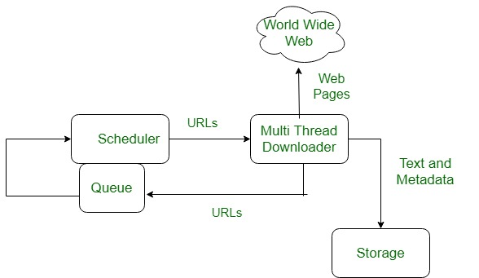
Here the browser displays a web page on the client machine when the user clicks on a line of text that is linked to a page on abd.com, the browser follows the hyperlink by sending a message to the abd.com server asking for the page.

Working of WWW
A Web browser is used to access web pages. Web browsers can be defined as programs which display text, data, pictures, animation and video on the Internet. Hyperlinked resources on the World Wide Web can be accessed using software interfaces provided by Web browsers. Initially, Web browsers were used only for surfing the Web but now they have become more universal.
The below diagram indicates how the Web operates just like client-server architecture of the internet. When users request web pages or other information, then the web browser of your system request to the server for the information and then the web server provide requested services to web browser back and finally the requested service is utilized by the user who made the request.
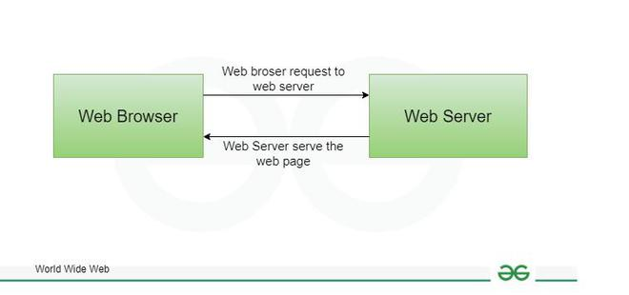
World Wide Web
Web browsers can be used for several tasks including conducting searches, mailing, transferring files, and much more. Some of the commonly used browsers are Internet Explorer, Opera Mini, and Google Chrome.

Features of WWW
- WWW is open source.
- It is a distributed system spread across various websites.
- It is a Hypertext Information System.
- It is Cross-Platform.
- Uses Web Browsers to provide a single interface for many services.
- Dynamic, Interactive and Evolving.

Components of the Web
There are 3 components of the web:
- Uniform Resource Locator (URL): serves as a system for resources on the web.
- Hyper Text Transfer Protocol (HTTP): specifies communication of browser and server.
- Hyper Text Markup Language (HTML): defines the structure, organisation and content of a web page.

Difference Between WWW and Internet
WWW | Internet
It is originated in 1989. | It is originated in 1960.
WWW is an interconnected network of websites and documents that can be accessed via the Internet. | Internet is used to connect a computer with other computer .
WWW used protocols such as HTTP | Internet used protocols such as TCP/IP
It is based on software. | It is based on hardware.
It is a service contained inside an infrastructure. | There is a entire infrastructure in internet.

HTTP
- HTTP stands for HyperText Transfer Protocol.
- It is a protocol used to access the data on the World Wide Web (www).
- The HTTP protocol can be used to transfer the data in the form of plain text, hypertext, audio, video, and so on.
- This protocol is known as HyperText Transfer Protocol because of its efficiency that allows us to use in a hypertext environment where there are rapid jumps from one document to another document.
- HTTP is similar to the FTP as it also transfers the files from one host to another host. But, HTTP is simpler than FTP as HTTP uses only one connection, i.e., no control connection to transfer the files.
- HTTP is used to carry the data in the form of MIME-like format.
- HTTP is similar to SMTP as the data is transferred between client and server. The HTTP differs from the SMTP in the way the messages are sent from the client to the server and from server to the client. SMTP messages are stored and forwarded while HTTP messages are delivered immediately.

Features of HTTP:
- Connectionless protocol: HTTP is a connectionless protocol. HTTP client initiates a request and waits for a response from the server. When the server receives the request, the server processes the request and sends back the response to the HTTP client after which the client disconnects the connection. The connection between client and server exist only during the current request and response time only.
- Media independent: HTTP protocol is a media independent as data can be sent as long as both the client and server know how to handle the data content. It is required for both the client and server to specify the content type in MIME-type header.
- Stateless: HTTP is a stateless protocol as both the client and server know each other only during the current request. Due to this nature of the protocol, both the client and server do not retain the information between various requests of the web pages.

HTTP Transactions
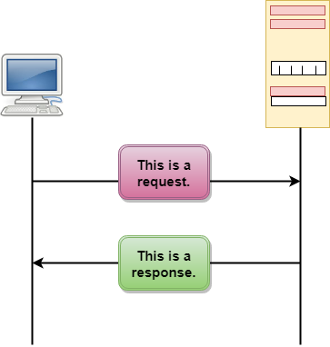
The above figure shows the HTTP transaction between client and server. The client initiates a transaction by sending a request message to the server. The server replies to the request message by sending a response message.

Messages
HTTP messages are of two types: request and response. Both the message types follow the same message format.
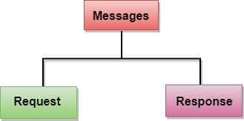
Request Message: The request message is sent by the client that consists of a request line, headers, and sometimes a body.
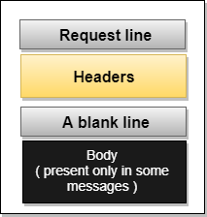
Response Message: The response message is sent by the server to the client that consists of a status line, headers, and sometimes a body.
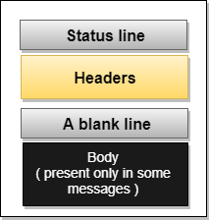

Uniform Resource Locator (URL)
- A client that wants to access the document in an internet needs an address and to facilitate the access of documents, the HTTP uses the concept of Uniform Resource Locator (URL).
- The Uniform Resource Locator (URL) is a standard way of specifying any kind of information on the internet.
- The URL defines four parts: method, host computer, port, and path.
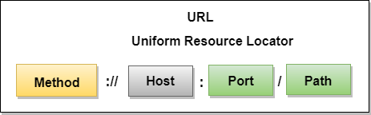
- Method: The method is the protocol used to retrieve the document from a server. For example, HTTP.
- Host: The host is the computer where the information is stored, and the computer is given an alias name. Web pages are mainly stored in the computers and the computers are given an alias name that begins with the characters "www". This field is not mandatory.
- Port: The URL can also contain the port number of the server, but it's an optional field. If the port number is included, then it must come between the host and path and it should be separated from the host by a colon.
- Path: Path is the pathname of the file where the information is stored. The path itself contain slashes that separate the directories from the subdirectories and files.
Information Technology…..(Continued)

Remote logging

Remote Login is a process in which user can login into remote site i.e. computer and use services that are available on the remote computer. With the help of remote login a user is able to understand result of transferring and result of processing from the remote computer to the local computer.
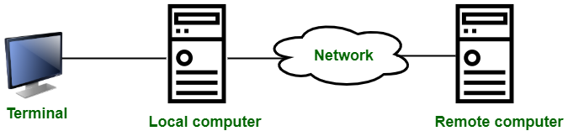

It is implemented through TELNET

- When the user types something on local computer, then local operating system accepts character.
- Local computer does not interpret the characters, it will send them to TELNET client.
- TELNET client transforms these characters to a universal character set called Network Virtual Terminal (NVT) characters and it will pass them to the local TCP/IP protocol Stack.
- Commands or text which is in the form of NVT, travel through Internet and it will arrive at the TCP/IP stack at remote computer.
- Characters are then delivered to operating system and which later on passed to TELNET server.
- Then TELNET server changes that characters to characters which can be understandable by remote computer.
- Remote operating system receives character from a pseudo-terminal driver, which is a piece of software that pretends that characters are coming from a terminal.
- Operating system then passes character to the appropriate application program.
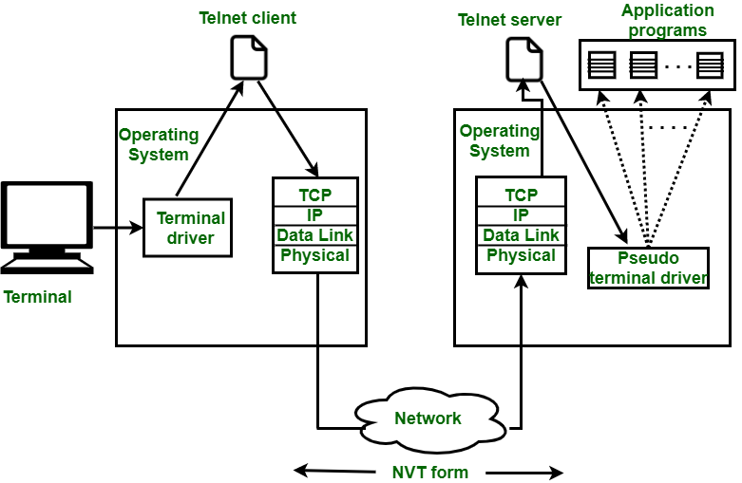
Figure – Remote login procedure

NVT Character Set :
- With NVT Character set, TELNET client translates characters into NVT form and deliver to network.
- TELNET server translates data and commands from NVT form to the other form that will be understandable by remote computer.
- NVT uses 2 sets of characters, one for data and other for control. Size of both characters is 8-bit bytes.
- For data, NVT is an 8-bit character set in which 7 lowest bits are same as ASCII and highest order bit is 0.
- For control characters, NVT uses an 8-bit character set in which the highest bit is set to 1.
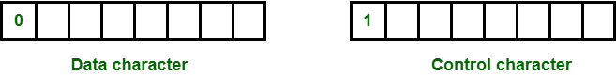
Figure – NVT Character Set

FTP(File Transfer Protocol)

File Transfer Protocol(FTP) is an application layer protocol that moves files between local and remote file systems. It runs on top of TCP, like HTTP. To transfer a file, 2 TCP connections are used by FTP in parallel: control connection and data connection.

What is File Transfer Protocol?
FTP is a standard communication protocol. There are various other protocols like HTTP which are used to transfer files between computers, but they lack clarity and focus as compared to FTP. Moreover, the systems involved in connection are heterogeneous, i.e. they differ in operating systems, directories, structures, character sets, etc the FTP shields the user from these differences and transfers data efficiently and reliably. FTP can transfer ASCII, EBCDIC, or image files. The ASCII is the default file share format, in this, each character is encoded by NVT ASCII. In ASCII or EBCDIC the destination must be ready to accept files in this mode. The image file format is the default format for transforming binary files.

File Transfer Protocol

Types of FTP
There are different ways through which a server and a client do a file transfer using FTP. Some of them are mentioned below:
- Anonymous FTP: Anonymous FTP is enabled on some sites whose files are available for public access. A user can access these files without having any username or password. Instead, the username is set to anonymous, and the password is to the guest by default. Here, user access is very limited. For example, the user can be allowed to copy the files but not to navigate through directories.
- Password Protected FTP: This type of FTP is similar to the previous one, but the change in it is the use of username and password.
- FTP Secure (FTPS): It is also called as FTP Secure Sockets Layer (FTP SSL). It is a more secure version of FTP data transfer. Whenever FTP connection is established, Transport Layer Security (TLS) is enabled.
- FTP over Explicit SSL/TLS (FTPES): FTPES helps by upgrading FTP Connection from port 21 to an encrypted connection.
- Secure FTP (SFTP): SFTP is not a FTP Protocol, but it is a subset of Secure Shell Protocol, as it works on port 22.

How does FTP work?
FTP is a client-server protocol that relies on two communications channels between the client and server: a command channel for controlling the conversation and a data channel for transmitting file content.
How FTP transfer works:
- A user typically needs to log on to the FTP server, although some servers make some or all of their content available without a login, a model known as anonymous FTP.
- The client initiates a conversation with the server when the user requests to download a file.
- Using FTP, a client can upload, download, delete, rename, move and copy files on a server.
FTP sessions work in active or passive modes:
- Active mode. After a client initiates a session via a command channel request, the server creates a data connection back to the client and begins transferring data.
- Passive mode. The server uses the command channel to send the client the information it needs to open a data channel. Because passive mode has the client initiating all connections, it works well across firewalls and network address translation gateways.
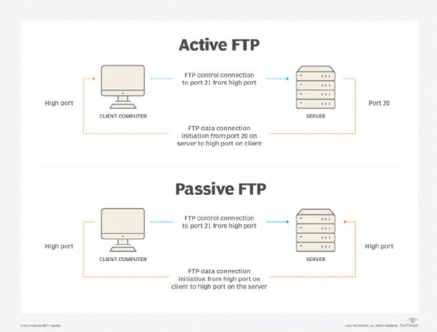Active FTP and passive FTP compared
Users can work with FTP via a simple command-line interface -- from a console or terminal window in Microsoft Windows, Apple macOS or Linux -- or with a dedicated graphical user interface. Web browsers can also serve as FTP clients.

Why is FTP important and what is it used for?
FTP is a standard network protocol that can enable expansive file transfer capabilities across IP networks. Without FTP, file and data transfer can be managed with other mechanisms -- such as email or an HTTP web service -- but those other options lack the clarity of focus, precision and control that FTP enables.
FTP is used for file transfers between one system and another, and it has several common use cases, including the following:
- Backup. FTP can be used by backup services or individual users to backup data from one location to a secured backup server running FTP services.
- Replication. Similar to backup, replication involves duplication of data from one system to another but takes a more comprehensive approach to provide higher availability and resilience. FTP can also be used to facilitate this.
- Access and data loading. FTP is also commonly used to access shared web hosting and cloud services as a mechanism to load data onto a remote system.

FTP types
There are several different ways an FTP server and client software can conduct a file transfer using FTP:
- Anonymous FTP. This is the most basic form of FTP. It provides support for data transfers without encrypting data or using a username and password. It's most commonly used for download of material that is allowed for unrestricted distribution. It works on port
- Password-protected FTP. This is also a basic FTP service, but it requires the use of a username and password, though the service might not be encrypted or secure. It also works on port 21.
- FTP Secure (FTPS). Sometimes referred to as FTP Secure Sockets Layer (FTP-SSL), this approach enables implicit Transport Layer Security (TLS) as soon as an FTP connection is established. FTPS was initially used to help enable a more secure form of FTP data transfer. It typically defaults to using port 990.
- FTP over explicit SSL/TLS (FTPES). This approach enables explicit TLS support by upgrading an FTP connection over port 21 to an encrypted connection. This is a commonly used approach by web and file sharing services to enable secure file transfers.
- Secure FTP (SFTP). This is technically not an FTP protocol, but it functions similarly. Rather, SFTP is a subset of the Secure Shell (SSH) protocol that runs over port 22. SSH is commonly used by systems administrators to remotely and securely access systems and applications, and SFTP provides a mechanism within SSH for secure file transfer.

FTP security
FTP was initially defined in 1971, predating TCP and IP, and it has been redefined several times since then to accommodate new technologies, including the use of TCP/IP, or Request for Comments 765 and RFC 959, and IPv6, or RFC 2428.
FTP has also undergone several updates to enhance FTP security. These include versions that encrypt via an implicit TLS connection (FTPS) or explicit TLS connection (FTPES) or that work with SFTP.
By default, FTP does not encrypt traffic, and individuals can capture packets to read usernames, passwords and other data. By encrypting FTP with FTPS or FTPES, data is protected, limiting the ability of an attacker to eavesdrop on a connection and steal data.
FTP may still be vulnerable to brute-force attacks against user/password authentication spoofing, an FTP bounce attack or a distributed denial-of-service attack.

History of FTP
The first specification for FTP was published as RFC 114 on April 16, 1971, and was written by Abhay Bhushan, then a student at the Massachusetts Institute of Technology. The original idea behind FTP was to enable the transfer of files over ARPANET, the precursor to the internet.
As the modern internet began to take shape, the FTP specification underwent several revisions to align with networking standards, including TCP/IP. In 1980, a new version of FTP was defined in RFC 765 by Jon Postel, a research scientist at the Information Sciences Institute at the University of Southern California at the time. Five years later, FTP was redefined yet again with RFC 959, which introduced new management capabilities for the protocol, including the ability to make and remove a file directory. Prior iterations of FTP were largely limited to transferring files to and from existing file directory structures.
In 1997, RFC 959 was updated with new capabilities defined in RFC 2228 to provide security capabilities. Two years later, FTP was updated with RFC 2428 to support the IPv6 protocol.

FTP clients
FTP clients are used to upload, download and manage files on a server. FTP clients include the following:
- FileZilla. This is a free FTP client for Windows, macOS and Linux that supports FTP, FTPS and SFTP.
- Transmit. This is an FTP client for macOS that supports FTP and SSH.
- WinSCP. This is a Windows FTP client that supports FTP, SSH and SFTP.
- WS_FTP. This is another Windows FTP client that supports SSH.
Client-Server Application

- client and server networking model is a model in which computers such as servers provide the network services to the other computers such as clients to perform a user based tasks. This model is known as client-server networking model.
- The application programs using the client-server model should follow the given below strategies:
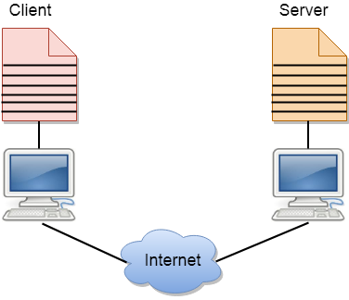
- An application program is known as a client program, running on the local machine that requests for a service from an application program known as a server program, running on the remote machine.
- A client program runs only when it requests for a service from the server while the server program runs all time as it does not know when its service is required.
- A server provides a service for many clients not just for a single client. Therefore, we can say that client-server follows the many-to-one relationship. Many clients can use the service of one server.
- Services are required frequently, and many users have a specific client-server application program. For example, the client-server application program allows the user to access the files, send e-mail, and so on. If the services are more customized, then we should have one generic application program that allows the user to access the services available on the remote computer.

Client
A client is a program that runs on the local machine requesting service from the server. A client program is a finite program means that the service started by the user and terminates when the service is completed.

Server
A server is a program that runs on the remote machine providing services to the clients. When the client requests for a service, then the server opens the door for the incoming requests, but it never initiates the service.
A server program is an infinite program means that when it starts, it runs infinitely unless the problem arises. The server waits for the incoming requests from the clients. When the request arrives at the server, then it responds to the request.

Advantages of Client-server networks:
- Centralized: Centralized back-up is possible in client-server networks, i.e., all the data is stored in a server.
- Security: These networks are more secure as all the shared resources are centrally administered.
- Performance: The use of the dedicated server increases the speed of sharing resources. This increases the performance of the overall system.
- Scalability: We can increase the number of clients and servers separately, i.e., the new element can be added, or we can add a new node in a network at any time.

Disadvantages of Client-Server network:
- Traffic Congestion is a big problem in Client/Server networks. When a large number of clients send requests to the same server may cause the problem of Traffic congestion.
- It does not have a robustness of a network, i.e., when the server is down, then the client requests cannot be met.
- A client/server network is very decisive. Sometimes, regular computer hardware does not serve a certain number of clients. In such situations, specific hardware is required at the server side to complete the work.
- Sometimes the resources exist in the server but may not exist in the client. For example, If the application is web, then we cannot take the print out directly on printers without taking out the print view window on the web.

Email

Basics of electronic mail
Email is a service which allows us to send the message in electronic mode over the internet. It offers an efficient, inexpensive and real time mean of distributing information among people.

E-Mail Address
Each user of email is assigned a unique name for his email account. This name is known as E-mail address. Different users can send and receive messages according to the e-mail address.
E-mail is generally of the form username@domainname. For example, abc@gmail.com is an e-mail address where webmaster is username and gmail.com is domain name.
- The username and the domain name are separated by @ (at) symbol.
- E-mail addresses are not case sensitive.
- Spaces are not allowed in e-mail address.

E-mail Message Components
E-mail message comprises of different components: E-mail Header, Greeting, Text, and Signature. These components are described in the following diagram:
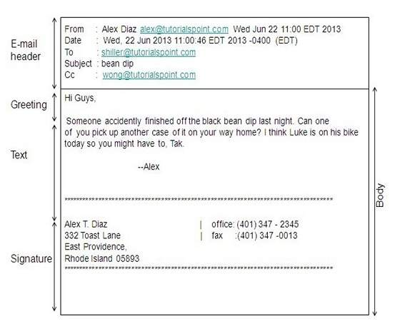

E-mail Header
The first five lines of an E-mail message is called E-mail header. The header part comprises of following fields:
- From
- Date
- To
- Subject
- CC
- BCC

From
The From field indicates the sender’s address i.e. who sent the e-mail.

Date
The Date field indicates the date when the e-mail was sent.

To
The To field indicates the recipient’s address i.e. to whom the e-mail is sent.

Subject
The Subject field indicates the purpose of e-mail. It should be precise and to the point.

CC
CC stands for Carbon copy. It includes those recipient addresses whom we want to keep informed but not exactly the intended recipient.

BCC
BCC stands for Black Carbon Copy. It is used when we do not want one or more of the recipients to know that someone else was copied on the message.

Greeting
Greeting is the opening of the actual message. Eg. Hi Sir or Hi Guys etc.

Text
It represents the actual content of the message.

Signature
This is the final part of an e-mail message. It includes Name of Sender, Address, and Contact Number.

Advantages
E-mail has prooved to be powerful and reliable medium of commmunication. Here are the benefits of E-mail:
- Reliable
- Convenience
- Speed
- Inexpensive
- Printable
- Global
- Generality

Reliable: Many of the mail systems notify the sender if e-mail message was undeliverable.

Convenience: There is no requirement of stationary and stamps. One does not have to go to post office. But all these things are not required for sending or receiving an mail.

Speed : E-mail is very fast. However, the speed also depends upon the underlying network.

Inexpensive: The cost of sending e-mail is very low.

Printable: It is easy to obtain a hardcopy of an e-mail. Also an electronic copy of an e-mail can also be saved for records.

Global: E-mail can be sent and received by a person sitting across the globe.

Generality: It is also possible to send graphics, programs and sounds with an e-mail.

Disadvantages
Apart from several benefits of E-mail, there also exists some disadvantages as discussed below:
- Forgery
- Overload
- Misdirection
- Junk
- No response

Forgery :E-mail doesn’t prevent from forgery, that is, someone impersonating the sender, since sender is usually not authenticated in any way.

Overload :Convenience of E-mail may result in a flood of mail.

Misdirection :It is possible that you may send e-mail to an unintended recipient.

Junk :Junk emails are undesirable and inappropriate emails. Junk emails are sometimes referred to as spam.

No Response: It may be frustrating when the recipient does not read the e-mail and respond on a regular basis.

